About the game

**(a) Game software documentation what you have implemented which structure (loops, conditions, arrays) you have implemented**

I have implemented the Input output streams, escape sequences, random function, data types, operators, conditional statements, and repetition structure (loops), functions, arrays, 2D arrays, dynamic arrays, dynamic 2D arrays, pointers.

**(b) Image of first look of game**

First look of the game is displaying a name of the game as below:

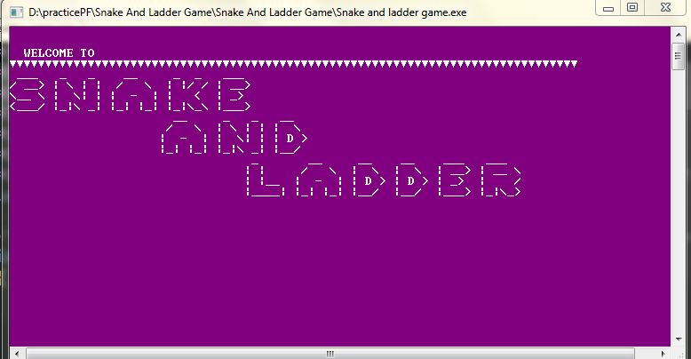

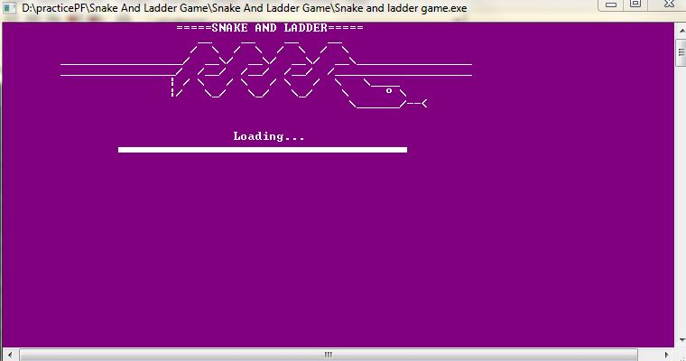

**(c)One image after snake effect**

When snake affects the player then it will give a sound and show the position after snake biting, you can also see the snake head and tail from at the top of the screen as shown below:

**BEFORE SNAKE EFFECT**

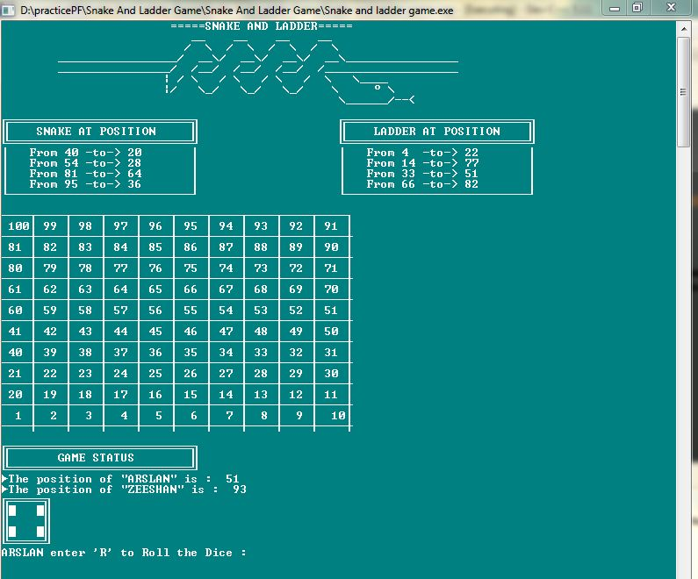

**AFTER SNAKE EFFECT**

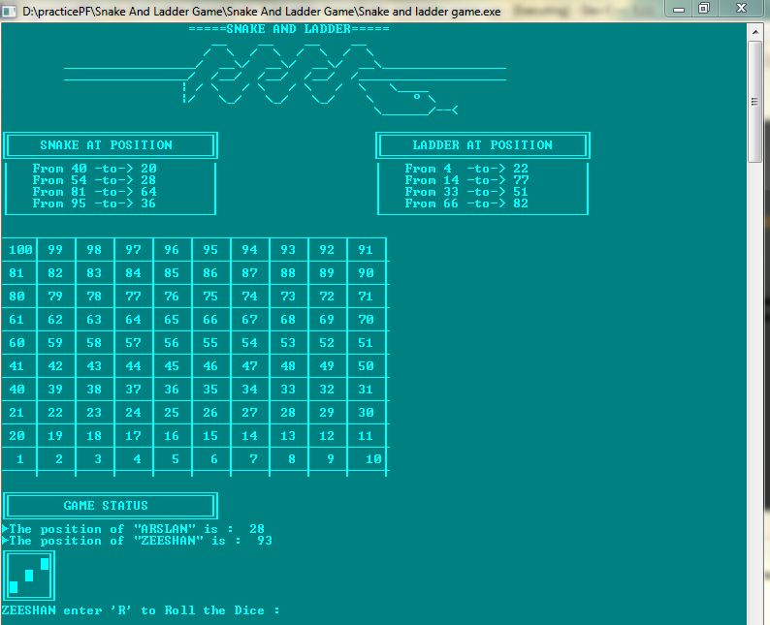

**(d) One image after ladder’s effect**

When ladder affects the player then it will give a sound and show the position after climbing effect of ladder, you can also see the ladder pick and drop positions at the top of the screen as shown below:

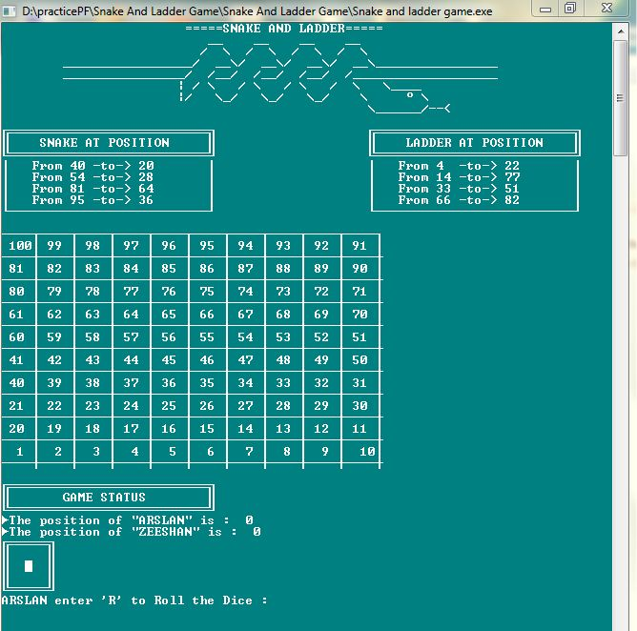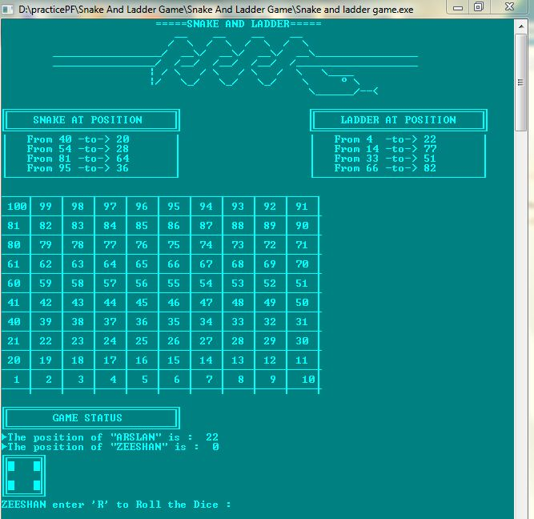

**AFTER LADDER EFFECT**

**BEFORE LADDER EFFECT**

**(e) Image after player win**

When any player wins then it will give a sound beep, and show a message and continue the second player to play as shown below:

**WINNER**

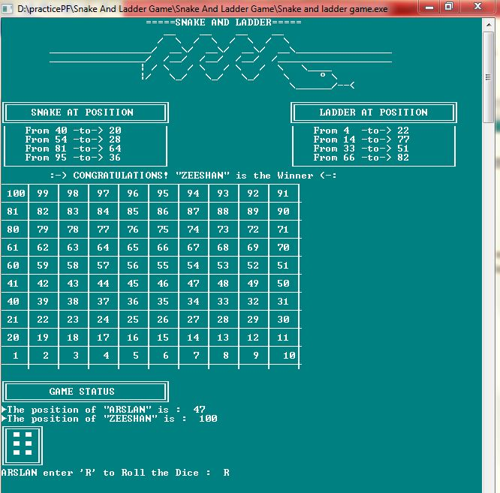

**(f) Concluding remarks about this software what you have learn from this coding**

After making this game software, I feel like I am able to solve all problems related to the C++ language.

After all, I thanks to my teacher.